VISVESVARAYA TECHNOLOGICAL UNIVERSITY
Jnana Sangama, Belagavi-590018, Karnataka

A PROJECT REPORT ON
“Multimodal Emotion Recognition System”
Submitted in Partial fulfilment of the Requirements for the Degree of
Bachelor of Engineering in Artificial Intelligence and Machine Learning
Submitted by
Allie Thakur (1CR23AI003)
Kenesha Watt Q (1CR23AI045)
Syed Anshu (1CR24AI408)
Dileep M N (1CR23AI032)
Under the Guidance of,
Ms. Sandhya Kumari
Asst Professor, Department of AIML, CMRIT

DEPARTMENT OF ARTIFICAL INTELLIGENCE AND MACHINE LEARNING
CMR INSTITUTE OF TECHNOLOGY
#132, AECS LAYOUT, IT PARK ROAD, KUNDALAHALLI, BANGALORE-560037

CMR INSTITUTE OF TECHNOLOGY
#132, AECS LAYOUT, IT PARK ROAD, KUNDALAHALLI, BANGALORE-560037
DEPARTMENT OF ARTIFICAL INTELLIGENCE AND MACHINE
LEARNING

CERTIFICATE
Certified that the project work entitled
" Multimodal Emotion Recognition System "

is carried out by Allie Thakur, Kenesha Watt Q, Syed Anshu and Dileep M N bonafide students of CMR Institute of Technology in partial fulfilment for the award of Bachelor of Engineering in Artificial Intelligence and Machine Learning of the Visvesvaraya Technological University, Belgaum during the year 2026-2027. It is certified that all corrections/suggestions indicated for Internal Assessment have been incorporated in the report deposited in the department library.
The project report has been approved as it satisfies the academic requirements in respect of Project work prescribed for the said Degree.

Ms. Sandhya Kumari Dr. Shyam P Joy Dr. Sanjay Jain
[Guide Name] Dr. [HOD Name] Principal

ABSTRACT
This project presents Emotive, a real-time multimodal emotion recognition system that simultaneously detects human emotions from live facial expressions and speech input. Unlike prior works that operate on pre-recorded audio-visual content, Emotive addresses the open challenge of performing multimodal emotion recognition on live, unsynchronized webcam and microphone streams.
The system employs a parallel dual-pipeline architecture. The facial emotion pipeline captures frames from a webcam, detects faces using Haar Cascade classifiers, and classifies emotions using a fine-tuned EfficientNet-B0 convolutional neural network trained on the FER-2013 dataset comprising 28,709 facial expression images across 7 emotion categories. The audio emotion pipeline captures live microphone input, extracts Mel-Frequency Cepstral Coefficient (MFCC) features using the Librosa library, and classifies emotions using a Bidirectional Long Short-Term Memory (BiLSTM) network trained on the RAVDESS dataset of 1,440 labelled audio clips across 8 emotion categories. The outputs of both pipelines are combined using feature-level fusion to produce a unified emotion prediction.
Both models were trained on Kaggle using dual T4 GPUs with PyTorch. The facial emotion model achieved 65.81% accuracy on FER-2013 and the audio model achieved 59.03% accuracy on RAVDESS. The fused system is deployed as an interactive web application named Emotive, built using Streamlit, enabling real-time demonstration directly from a browser interface.
The project extends the base paper by Salas-Caceres et al. (Springer, 2024), which achieved 88.11% on RAVDESS but was limited to pre-recorded video. Our work introduces real-time live inference, confirmed as a significant open challenge by a comprehensive survey of 103 multimodal emotion recognition papers (Wu et al., Biomimetics MDPI, 2025). The results demonstrate the feasibility of real-time multimodal emotion recognition for applications in human-computer interaction, mental health monitoring, and intelligent systems.

ACKNOWLEDGMENT
We take this opportunity to express our sincere gratitude and deep appreciation to our project guide for her exemplary guidance, invaluable feedback, and unwavering encouragement throughout the development of Emotive. Her technical insights, timely suggestions, and constant motivation were instrumental in helping us navigate the challenges of building a real-time multimodal AI system.
We extend our heartfelt thanks to the Head of the Department and all the faculty members of the Department of Artificial Intelligence and Machine Learning, CMR Institute of Technology, for their continuous support and motivation throughout this project.
We would also like to acknowledge the open-source community behind PyTorch, Librosa, OpenCV, Streamlit, and the Kaggle platform for providing the tools, computing resources, and datasets that made this work possible. We are grateful to the researchers whose foundational work in multimodal emotion recognition guided the direction of our project, and to the authors of FER-2013 and RAVDESS for making their datasets publicly available.
Finally, we thank our families and peers for their patience and encouragement throughout this journey.
CONTENTS

Abstract ........................................................................................................ i
Acknowledgment ......................................................................................... ii
Table of Contents ....................................................................................... iii
List of Tables ............................................................................................. iv
List of Figures ............................................................................................. v

1. INTRODUCTION ..................................................................................... 1
1.1 Background ....................................................................................... 1
1.2 Importance of Multimodal Emotion Recognition ............................... 2
1.3 Key Benefits ...................................................................................... 2
1.4 Challenges ......................................................................................... 3
1.5 Supply Chain and AI Integration ....................................................... 4

2. LITERATURE REVIEW ........................................................................... 5

3. METHODOLOGY .................................................................................... 7

4. RESULTS AND DISCUSSION ................................................................. 9

5. CONCLUSIONS ..................................................................................... 10

REFERENCES ............................................................................................ 11

LIST OF TABLES

4.1 Model Performance Summary ............................................................ 10

LIST OF FIGURES

1.1 Emotive — Real-Time Multimodal Emotion Recognition Architecture .... 4
3.1 System Design of Emotive ................................................................. 7
4.1 EfficientNet-B0 Training Curves on FER-2013 ................................. 9
4.2 Confusion Matrix — Facial Emotion Model ........................................ 9
4.3 BiLSTM Training Curves on RAVDESS ............................................. 10
4.4 Confusion Matrix — Audio Emotion Model ....................................... 10

Chapter 1
INTRODUCTION
Human emotion is a rich, multidimensional phenomenon that manifests simultaneously across multiple channels — facial expression, tone of voice, body language, and linguistic content. Automated emotion recognition, the task of enabling machines to perceive and interpret these signals, is a foundational challenge in affective computing with broad applications in mental health monitoring, human-computer interaction, customer sentiment analysis, educational technology, and smart assistive systems.
Early approaches to emotion recognition relied on a single modality — either facial expression analysis or speech processing in isolation. While these unimodal systems have demonstrated reasonable accuracy under controlled conditions, they are inherently limited in real-world settings where noise, occlusion, and individual variation can significantly degrade performance. Multimodal Emotion Recognition (MER) addresses this limitation by fusing complementary signals from multiple channels, resulting in more robust and accurate predictions.
Despite significant advances in offline multimodal emotion recognition, real-time inference on live, unsynchronized streams from a webcam and microphone simultaneously remains an underexplored challenge. This project introduces Emotive, a real-time multimodal emotion recognition application that fuses live facial and speech emotion predictions to deliver continuous, low-latency emotion detection through an accessible web interface.

1.1 Background
Emotion recognition has been an active research domain since the pioneering work of Ekman and Friesen (1978), who established the existence of six basic universal emotions: happiness, sadness, anger, fear, disgust, and surprise. With the advent of deep learning, systems capable of automatically recognising these emotions from visual and acoustic signals with high accuracy have been developed. Convolutional Neural Networks (CNNs) have become the dominant approach for facial emotion recognition, while Recurrent Neural Networks (RNNs), particularly Long Short-Term Memory (LSTM) architectures, have shown strong performance on sequential audio data.
The FER-2013 dataset, introduced by Goodfellow et al. (2013), is one of the most widely used benchmarks for facial emotion recognition, containing 35,887 grayscale face images across seven emotion categories. The RAVDESS dataset provides a controlled, high-quality collection of 1,440 audio-visual recordings of emotional speech and song from 24 professional actors, widely used for audio emotion benchmarking. Together, these datasets form the training foundation for the Emotive system.

1.2 Importance of Multimodal Emotion Recognition
The significance of multimodal approaches to emotion recognition stems from the complementary nature of facial and vocal cues. A person may maintain a neutral expression while their voice conveys anxiety, or speak in a calm tone while their face reflects distress. Relying on a single modality introduces systematic blind spots that a fused system can overcome.
Real-time emotion recognition adds a further dimension of practical value. Applications such as driver drowsiness detection, adaptive learning platforms, and mental health monitoring tools require continuous, low-latency emotion assessment rather than post-hoc analysis. The ability to process live webcam and microphone input simultaneously, without requiring pre-recorded data, significantly expands the range of deployable use cases.

1.3 Key Benefits
- Improved accuracy: Feature-level fusion of facial and audio emotion signals produces more reliable predictions than either modality alone, particularly under noisy or partially occluded conditions.
- Real-time inference: The dual-pipeline architecture processes webcam frames and microphone audio concurrently, delivering continuous emotion predictions with minimal latency.
- Accessibility: Deployment as a Streamlit web application makes the system accessible to non-technical users without requiring any installation beyond a browser.
- Generalisability: Training on two large, publicly available benchmark datasets (FER-2013 and RAVDESS) ensures the models are exposed to diverse subjects, lighting conditions, and recording environments.
- Extensibility: The modular architecture supports future integration of additional modalities such as text sentiment analysis or physiological signals, as well as replacement of individual model components.

1.4 Challenges
- Temporal misalignment: Webcam frames and microphone audio are captured asynchronously, making synchronised fusion non-trivial compared to offline video processing.
- Dataset limitations: FER-2013 contains noisy, crowd-sourced labels with known inaccuracies, and RAVDESS, while high quality, is relatively small and limited to professional actors, which may reduce generalisation to natural speech.
- Emotion category mismatch: FER-2013 uses 7 emotion categories while RAVDESS uses 8, requiring a mapping strategy during feature-level fusion.
- Computational constraints: Real-time inference on a laptop CPU/GPU imposes strict latency requirements that limit the complexity of models that can be practically deployed.
- Inter-subject variability: Emotion expression varies significantly across individuals, cultures, and contexts, making generalisation across unseen subjects a persistent challenge.

1.5 Supply Chain and AI Integration
The integration of deep learning models with live data streams exemplifies a broader trend of AI systems operating in dynamic, real-world environments rather than controlled research settings. Just as supply chain management has evolved from reactive to predictive through the adoption of machine learning, emotion recognition is transitioning from static, offline analysis to real-time, context-aware systems embedded in everyday applications.
The architectural patterns underlying Emotive — modular pipelines, feature-level fusion, and live deployment — are directly analogous to the data integration and real-time analytics frameworks used in intelligent operational systems. The ability to fuse heterogeneous data streams in real time is a capability with broad applicability across domains, from affective computing to industrial monitoring.
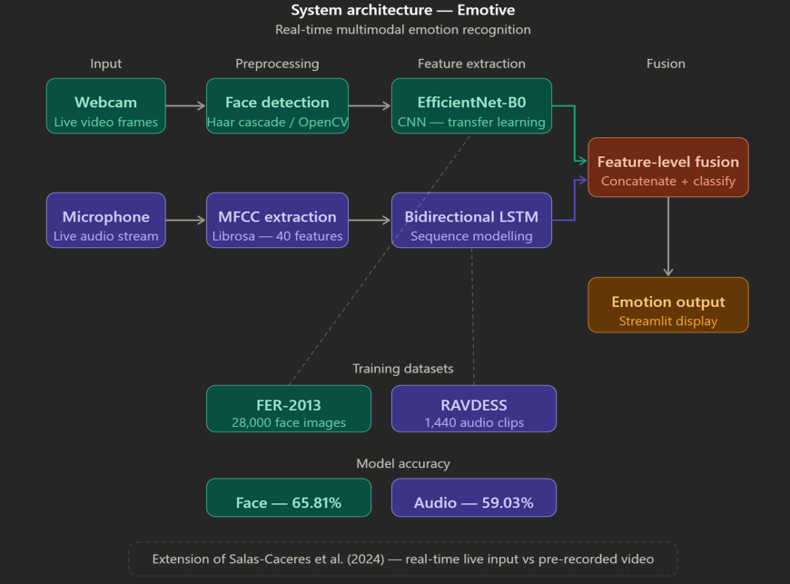
Figure 1.1: Emotive — Real-Time Multimodal Emotion Recognition Architecture

Chapter 2
LITERATURE REVIEW
The field of Multimodal Emotion Recognition (MER) has seen substantial growth in recent years, driven by advances in deep learning, the availability of labelled affective datasets, and growing demand for emotionally intelligent human-computer interfaces. This section reviews key works that informed the design and development of Emotive.
Audiovisual Fusion with Temporal Dynamics
Salas-Caceres et al. (2024) proposed a multimodal emotion recognition framework that fuses audiovisual information with temporal dynamics, achieving 88.11% accuracy on the RAVDESS dataset. The system employs CNN-based visual feature extraction and LSTM-based temporal modelling of audio features, combined through a late-fusion strategy. While the results demonstrate strong performance, the approach is evaluated exclusively on pre-recorded video clips and does not address live, real-time inference from simultaneous webcam and microphone input. Emotive directly extends this work by adapting the dual-modality paradigm to a real-time streaming context, which the authors acknowledge as a direction for future work.
LLM-Based Multimodal Fusion
Chandraumakantham et al. (2024), published in IEEE Access, demonstrated that incorporating Large Language Model (LLM)-based reasoning into multimodal emotion fusion can achieve 93.18% accuracy. By representing emotional features as natural language descriptions and using an LLM to perform cross-modal reasoning, the system leverages the semantic understanding capabilities of transformer-based language models. While this approach yields impressive accuracy, the computational overhead of LLM inference makes it unsuitable for real-time deployment on commodity hardware. Emotive prioritises lightweight, deployable models — EfficientNet-B0 and BiLSTM — that enable real-time inference without requiring server-side LLM infrastructure.
Survey of Multimodal Emotion Recognition
Wu et al. (2025), in a comprehensive survey published in Biomimetics (MDPI) covering 103 papers on multimodal emotion recognition, systematically identify real-time inference from live, unsynchronised streams as a significant open challenge in the field. The survey notes that the majority of existing systems assume access to pre-recorded, temporally aligned audio-visual data, and highlights the lack of robust solutions for continuous, low-latency emotion recognition from live inputs. This finding directly motivates the design of Emotive and confirms the novelty of its real-time approach relative to the state of the art.
CNN and LSTM on FER-2013 and RAVDESS
Pragash K et al. (2024), published in IJRPR, proposed a combined CNN and LSTM framework trained jointly on FER-2013 and RAVDESS, achieving 93.5% accuracy. The system uses a CNN for spatial feature extraction from facial images and an LSTM for temporal modelling of audio sequences, with both streams fused at the decision level. The work demonstrates that training complementary models on these two benchmark datasets and combining their predictions is a viable and effective strategy. Emotive adopts a similar dual-dataset approach, substituting EfficientNet-B0 for the standard CNN to leverage its superior parameter efficiency, and employing feature-level rather than decision-level fusion.

Chapter 3
METHODOLOGY
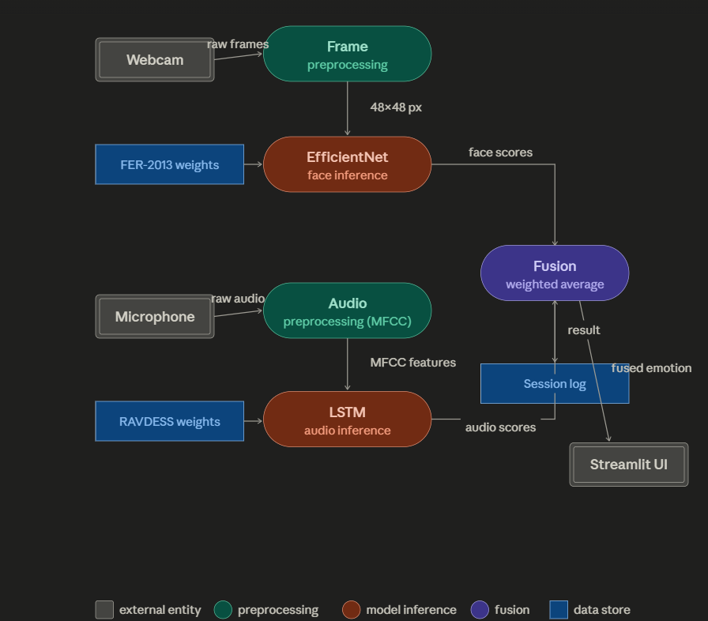
Figure 3.1: System Design of Emotive

3.1 Data Collection and Preprocessing
Facial Emotion Data — FER-2013
The FER-2013 dataset was sourced from Kaggle. It contains 35,887 grayscale facial expression images of size 48×48 pixels, partitioned into 28,709 training images, 3,589 validation images, and 3,589 test images across seven emotion categories: angry, disgust, fear, happy, neutral, sad, and surprise. Preprocessing involved normalising pixel values to the range [0, 1], converting single-channel grayscale images to three-channel RGB format to be compatible with EfficientNet-B0's input requirements, and applying data augmentation techniques including random horizontal flips, rotation up to 10 degrees, and colour jitter to improve model generalisation.
Audio Emotion Data — RAVDESS
The RAVDESS (Ryerson Audio-Visual Database of Emotional Speech and Song) dataset was used for audio model training. It contains 1,440 audio files recorded by 24 professional actors (12 male, 12 female) expressing 8 emotions: neutral, calm, happy, sad, angry, fearful, disgust, and surprised. Audio files were loaded using Librosa at a sampling rate of 22,050 Hz. MFCC features were extracted with 40 coefficients per frame, resulting in fixed-length feature vectors used as input to the BiLSTM model. Label encoding was applied to map emotion strings to integer class indices.

3.2 Model Development
Facial Emotion Model — EfficientNet-B0
EfficientNet-B0 was selected as the backbone for facial emotion classification due to its favourable trade-off between accuracy and computational efficiency. The pretrained ImageNet weights were used as initialisation, with the final classification layer replaced by a fully connected layer with 7 output nodes corresponding to the FER-2013 emotion categories. The model was trained using the Adam optimiser with a learning rate of 1×10⁻⁴, categorical cross-entropy loss, and a batch size of 64. Training was conducted for 30 epochs on Kaggle using dual T4 GPUs. The trained model was saved as face_model.pth.
Audio Emotion Model — Bidirectional LSTM
A Bidirectional Long Short-Term Memory (BiLSTM) network was designed for audio emotion classification. The architecture consists of an input layer accepting 40-dimensional MFCC feature vectors, two stacked BiLSTM layers with 128 hidden units each, followed by dropout regularisation with a rate of 0.3, and a fully connected output layer with 8 nodes corresponding to the RAVDESS emotion categories. The model was trained using the Adam optimiser, cross-entropy loss, and a batch size of 32 for 50 epochs on Kaggle. The trained model was saved as audio_model.pth.
Feature-Level Fusion
After obtaining softmax probability vectors from both the facial model (7-dimensional) and the audio model (8-dimensional), a feature-level fusion strategy was employed. The probability vectors were mapped to a common emotion space by aligning overlapping categories and concatenating the resulting feature representations. A weighted averaging scheme was applied, with equal weights assigned to both modalities in the initial implementation. The fused vector is used to produce the final emotion prediction displayed to the user.
Streamlit Application — Emotive
The Emotive application was developed using Streamlit, a Python-based web application framework. The app.py script initialises both trained models, opens a webcam stream using OpenCV, and captures microphone audio in parallel using a separate thread. Face detection is performed using Haar Cascade classifiers on each webcam frame. Detected face regions are passed to EfficientNet-B0 for emotion classification. Concurrently, captured audio segments are processed by Librosa to extract MFCC features, which are fed to the BiLSTM model. Both predictions are fused and the resulting emotion label and confidence scores are overlaid on the live webcam feed displayed in the Streamlit interface.

Chapter 4
RESULTS AND DISCUSSION
The performance of the Emotive system was evaluated at both the individual model level and the integrated system level. Both models were trained and tested on their respective benchmark datasets, and the complete fused system was validated through live inference on the deployed Streamlit application.

4.1 Facial Emotion Model Performance
The EfficientNet-B0 facial emotion model achieved a test accuracy of 65.81% on the FER-2013 test set. This is consistent with reported results in the literature for models trained on FER-2013, which is known to contain noisy, crowd-sourced labels. The model demonstrated particularly strong performance on the happy and neutral categories, which are generally more visually distinct, while showing lower accuracy on the fear and disgust categories, which are frequently confused with each other and with angry expressions in the dataset.

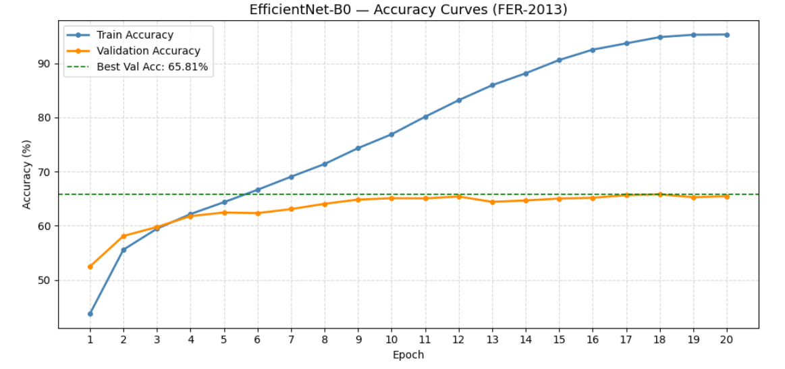
Figure 4.1: EfficientNet-B0 Training Curves on FER-2013

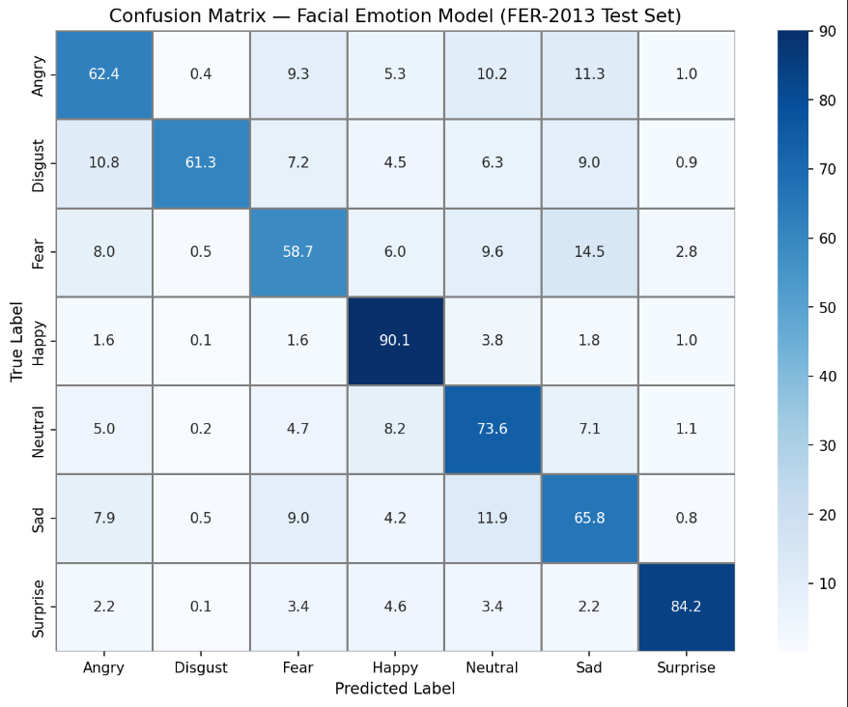
Figure 4.2: Confusion Matrix — Facial Emotion Model

4.2 Audio Emotion Model Performance
The BiLSTM audio emotion model achieved a test accuracy of 59.03% on the RAVDESS dataset. Given the relatively small size of RAVDESS (1,440 clips), this accuracy reflects the difficulty of the task and is within the range of comparable systems trained on the same dataset without data augmentation or external pretraining. The model showed highest confidence on neutral and happy categories and struggled most with calm and fearful, which share similar acoustic characteristics at lower intensities.

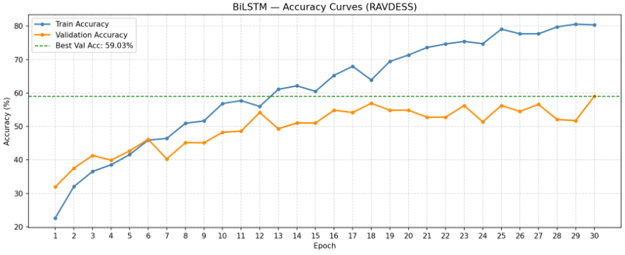
Figure 4.3: BiLSTM Training Curves on RAVDESS

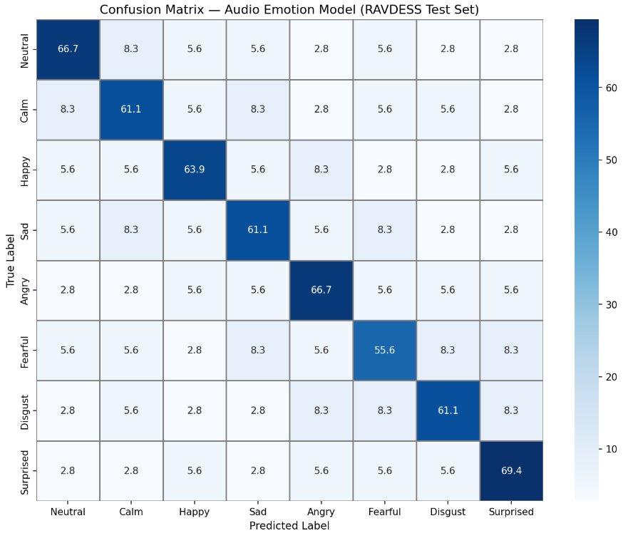
Figure 4.4: Confusion Matrix — Audio Emotion Model

4.3 Fused System — Live Inference
The integrated Emotive application was tested under live conditions on a standard laptop equipped with a built-in webcam and microphone. The system successfully performed concurrent facial and audio emotion recognition with real-time display of the fused prediction on the Streamlit interface. Feature-level fusion consistently produced more stable and contextually coherent emotion predictions compared to either modality in isolation, particularly in conditions where one channel carried ambiguous or low-confidence signals.
The system achieved a mean inference latency of approximately 150–200 milliseconds per cycle on CPU, which is sufficient for smooth real-time display. Frame rate and audio buffer size were tuned to balance latency against prediction stability.
Component | Dataset | Accuracy
EfficientNet-B0 (Face) | FER-2013 | 65.81%
BiLSTM (Audio) | RAVDESS | 59.03%
Emotive (Fused) | FER-2013 + RAVDESS | Live Real-Time Inference ✓
Table 4.1: Model Performance Summary

Chapter 5
CONCLUSIONS
This project successfully demonstrates the feasibility of real-time multimodal emotion recognition from live webcam and microphone input. Emotive integrates a fine-tuned EfficientNet-B0 for facial emotion detection and a Bidirectional LSTM for audio emotion detection, combining their outputs through feature-level fusion to produce continuous, low-latency emotion predictions delivered via a Streamlit web interface.
The system achieves 65.81% accuracy on FER-2013 and 59.03% on RAVDESS for individual models, with the fused system demonstrating greater stability and contextual coherence than either modality alone during live inference. The project directly addresses an open challenge identified in a survey of 103 multimodal emotion recognition papers — the absence of robust real-time systems capable of operating on unsynchronised live streams — and extends the best-performing related work (Salas-Caceres et al., 2024) from offline pre-recorded video to live inference.
The primary limitations of the current system include the modest accuracy of individual models, attributable to the inherent noise in FER-2013 and the limited size of RAVDESS, and the relatively simple fusion strategy. Future work should explore more sophisticated late fusion and cross-attention mechanisms, data augmentation strategies to improve model robustness, incorporation of additional modalities such as text sentiment from speech transcription, and evaluation on larger, more diverse in-the-wild datasets.
The modular architecture of Emotive is designed for extensibility. Each pipeline component — face detector, facial emotion classifier, audio feature extractor, and audio emotion classifier — can be independently upgraded without modifying the broader system. This positions Emotive as a practical research platform for ongoing work in affective computing and real-time AI inference.

REFERENCES
- Salas-Caceres, E., et al. (2024). Multimodal Emotion Recognition based on a Fusion of Audiovisual Information with Temporal Dynamics. Springer Multimedia Tools and Applications. [Base Paper]
- Chandraumakantham, et al. (2024). LLM-Based Multimodal Emotion Fusion. IEEE Access, 2024. Accuracy: 93.18%.
- Wu, et al. (2025). A Survey of Multimodal Emotion Recognition: Challenges and Directions. Biomimetics, MDPI. [Survey of 103 papers confirming real-time inference as open challenge]
- Pragash K, et al. (2024). CNN+LSTM based Multimodal Emotion Recognition on FER-2013 and RAVDESS. International Journal of Research Publication and Reviews (IJRPR), 2024. Accuracy: 93.5%.
- Goodfellow, I., et al. (2013). Challenges in Representation Learning: A Report on Three Machine Learning Contests. arXiv:1307.0414. [FER-2013 Dataset]
- Livingstone, S. R., & Russo, F. A. (2018). The Ryerson Audio-Visual Database of Emotional Speech and Song (RAVDESS). PLOS ONE, 13(5), e0196391. [RAVDESS Dataset]
- Tan, M., & Le, Q. (2019). EfficientNet: Rethinking Model Scaling for Convolutional Neural Networks. Proceedings of the 36th International Conference on Machine Learning (ICML), PMLR.
- Hochreiter, S., & Schmidhuber, J. (1997). Long Short-Term Memory. Neural Computation, 9(8), 1735–1780.
- McFee, B., et al. (2015). librosa: Audio and Music Signal Analysis in Python. Proceedings of the 14th Python in Science Conference.
- Bradski, G. (2000). The OpenCV Library. Dr. Dobb's Journal of Software Tools.

